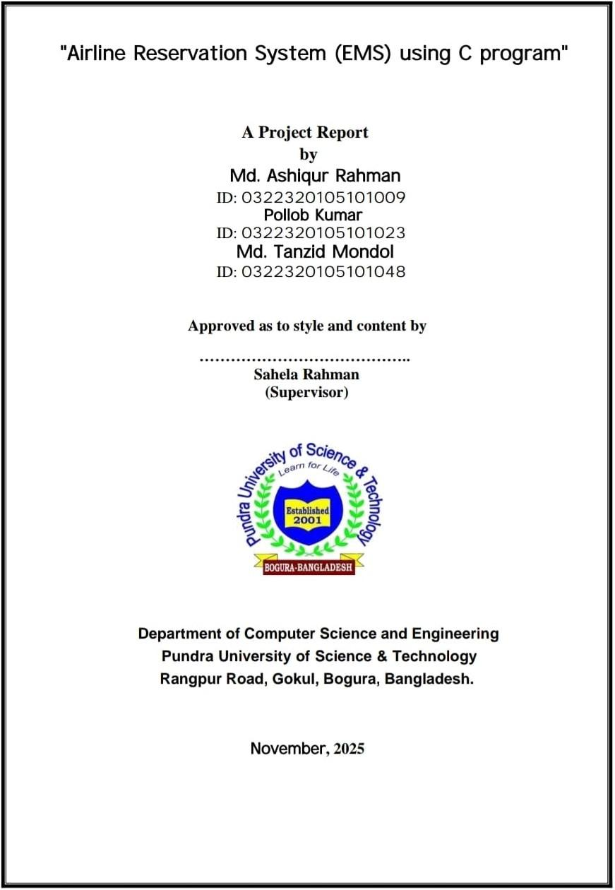

Acknowledgement
We would like to express our sincere gratitude to Almighty Allah for granting me the strength, patience, and wisdom to complete this project successfully.
My deepest appreciation goes to our respected supervisor Sahela Rahman, Department of CSE, Pundra University of Science & Technology, for continuous guidance, feedback, and motivation. Her valuable suggestions shaped this project at every stage.
We also extend thanks to the Head of the CSE Department and all faculty members for their cooperation and academic support. Our classmates and group partners also deserve recognition for their collaborative effort.
Finally, we thank my parents for their unconditional support, encouragement, and inspiration throughout my academic journey.

Md. Ashiqur Rahaman
Pollob Kumar
Md. Tanzid Mondol

Abstract
This project presents the development of an Airline Reservation System using the C programming language. The system enables users to view available flights, book tickets, cancel reservations, and check booking status through a menu-driven interface. C file handling is used to manage booking details and flight information.
The project follows the Software Development Life Cycle (SDLC), including requirement analysis, design, implementation, and testing. The report contains detailed diagrams, use cases, process modeling, and test results. Future enhancements such as GUI integration, online database connectivity, and advanced security mechanisms are also discussed.
This system demonstrates how fundamental programming concepts can be used to design a simplified real-world reservation solution.

Table of Contents
- Introduction
  - 1.1 Background
  - 1.2 Problem Statement
  - 1.3 Motivation
  - 1.4 Objectives
  - 1.5 Report Structure
- Background Study
  - 2.1 What is a Reservation System?
  - 2.2 Airline Automation History
  - 2.3 Related Works
  - 2.4 Comparative Study
  - 2.5 Problem Scope
  - 2.6 Challenges
- Requirement Specification
  - 3.1 Functional Requirements
  - 3.2 Non-functional Requirements
  - 3.3 Logical Data Model
  - 3.4 Design Requirements
- Design Specification
  - 4.1 System Architecture
  - 4.2 Front-end Design
  - 4.3 Back-end Design
  - 4.4 File Structure
  - 4.5 Interaction & UX Design
- Implementation & Testing
  - 5.1 Programming Environment
  - 5.2 Implemented Modules
  - 5.3 Sample Code Snippets
  - 5.4 Testing Strategy
  - 5.5 Test Results
- Conclusion & Future Scope
  - 6.1 Conclusion
  - 6.2 Future Work
- References

Chapter 1: Introduction

1.1 Background
Airline Reservation Systems (ARS) are used to manage ticket booking, flight scheduling, and seat allocation for passengers. Modern ARS systems automate the entire process.

1.2 Problem Statement
Manual ticket booking is inefficient, slow, and error-prone. A computerized system reduces human effort and increases reliability.

1.3 Motivation
The global airline industry relies heavily on automation, inspiring the creation of a simplified C-based reservation system as an academic project.

1.4 Objectives
- Develop a C-based flight reservation system.
- Provide a menu-driven interface.
- Utilize file handling for data storage.
- Implement structured programming.
- Document the entire development cycle.

1.5 Report Structure
The report includes background study, requirement analysis, system design, implementation, testing, and conclusion.

Chapter 2: Background Study

2.1 What is a Reservation System?
A reservation system is software that helps customers book services by managing availability and confirming bookings.

2.2 Airline Automation History
Early airline systems used mainframe architectures. Modern systems use web applications, cloud servers, and distributed databases.

2.3 Related Works
Several existing systems include: - Galileo Reservation System - Sabre - Amadeus GDS

2.4 Comparative Study
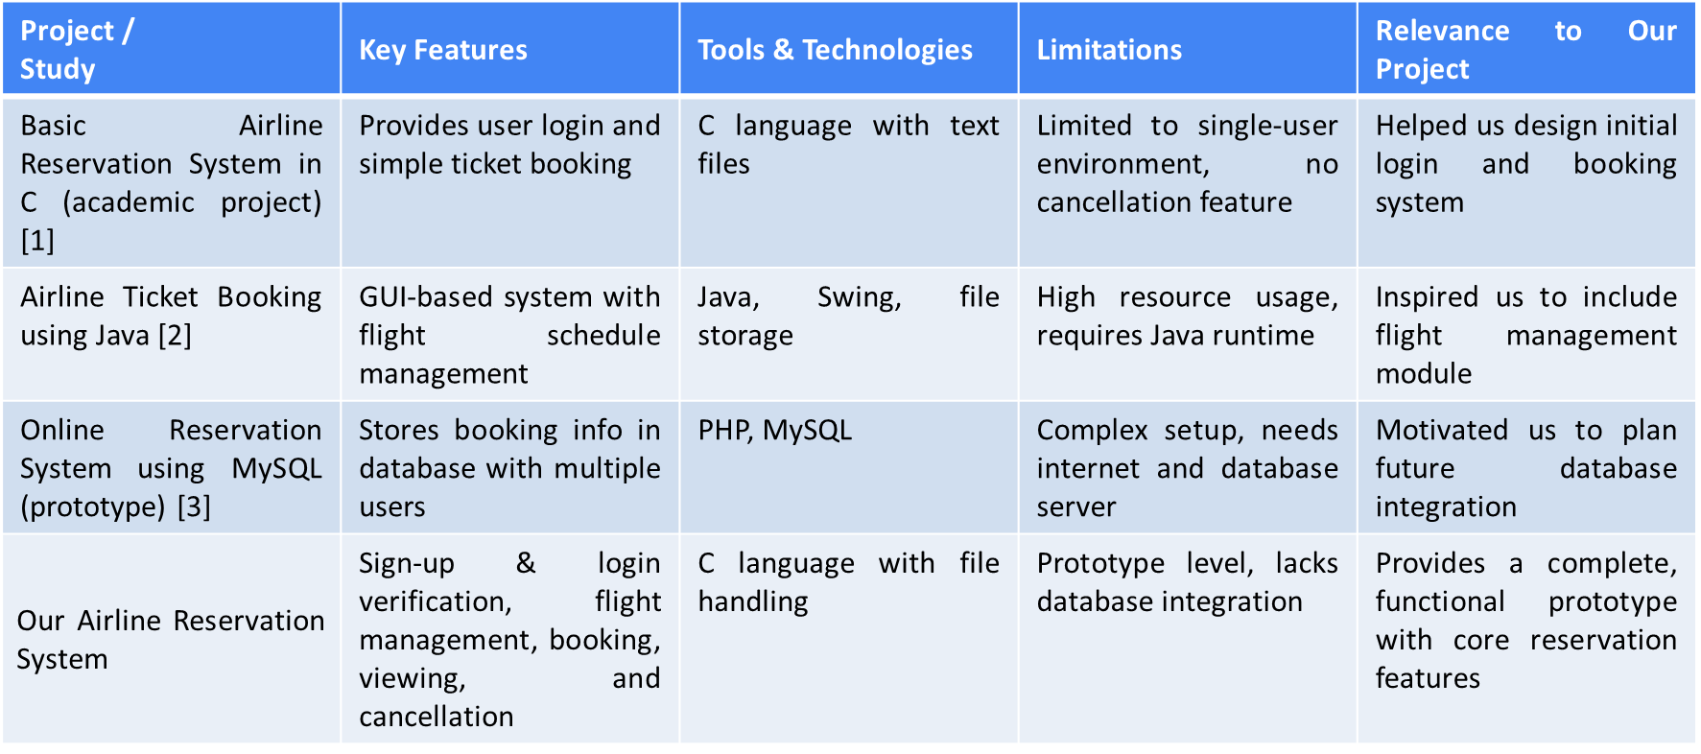

2.5 Scope
This system supports basic reservation operations only.

2.6 Challenges
- Structuring code
- Managing file operations
- Ensuring correct data retrieval

Chapter 3: Requirement Specification

3.1 Functional Requirements
- View available flights
- Book a flight ticket
- Cancel a ticket
- Display booking details

3.2 Non-functional Requirements
- Performance
- Reliability
- Accuracy
- Usability

3.3 Logical Data Model
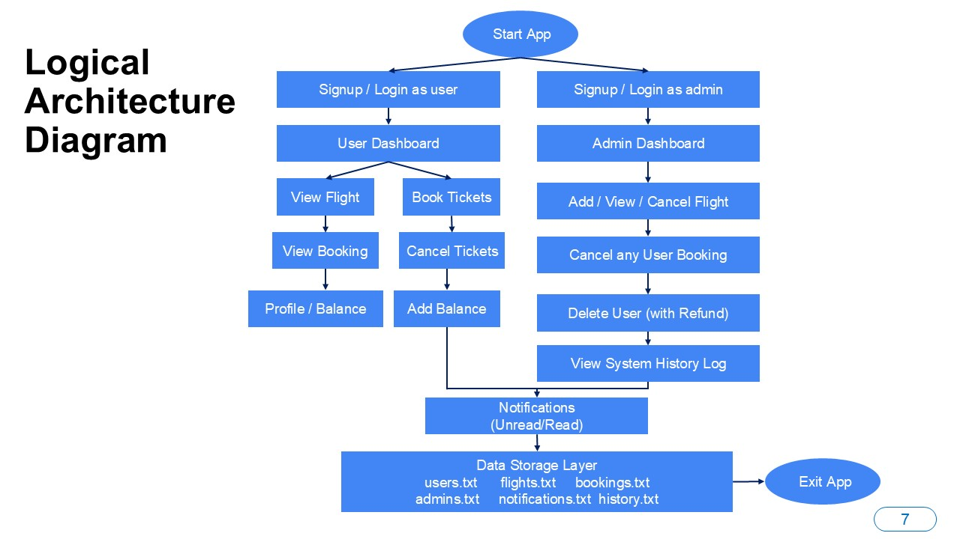

3.4 Design Requirements
- Modular code structure
- Clear function definitions
- File-based database

Chapter 4: Design Specification

4.1 System Architecture
Presentation Layer → Logic Layer → Data Layer

4.2 Front-end Design
Menu-driven console interface.

4.3 Back-end Design
Flight and booking information stored using .txt files.

4.4 File Structure

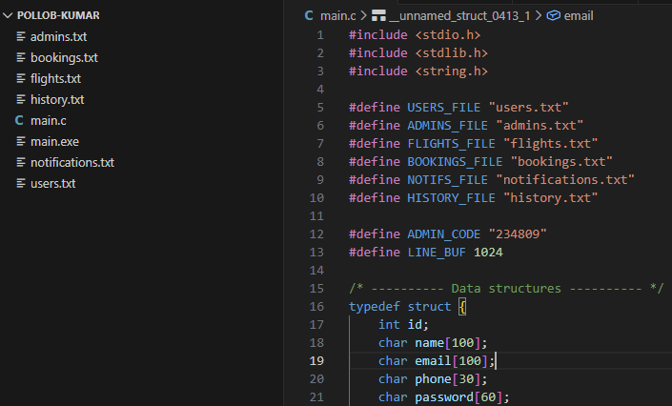

4.5 UX Design
Simple navigational structure for users.

Chapter 5: Implementation & Testing

5.1 Programming Environment
- Language: C
- Compiler: GCC
- OS: Windows/Linux

5.2 Implemented Modules
- Flight display module
- Booking module
- Cancel module
- Status module

5.3 Sample Code Snippets

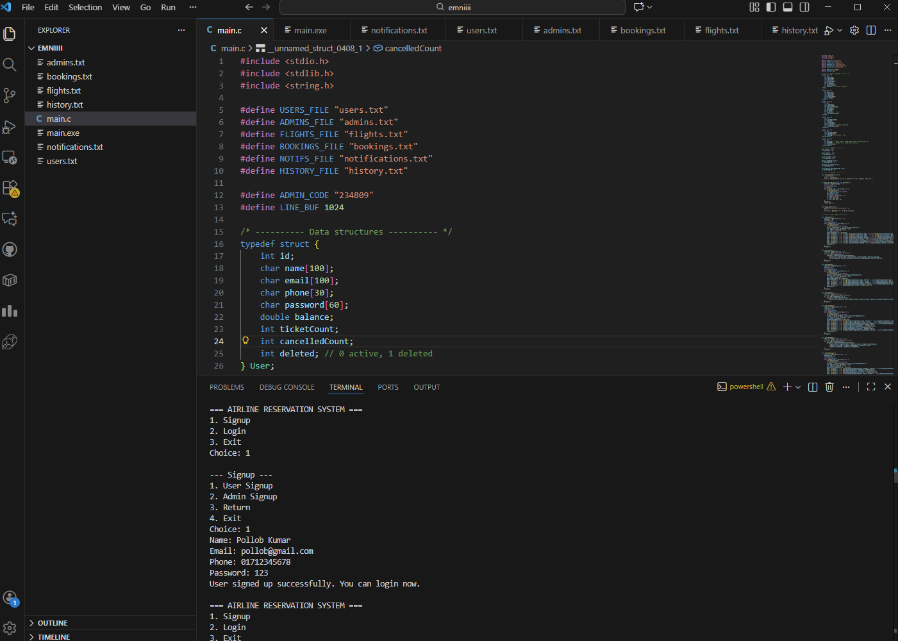

5.4 Testing Strategy
Black-box testing performed using different input sets.

5.5 Test Results

=== AIRLINE RESERVATION SYSTEM ===  1. Signup  2. Login  3. Exit  Choice: 1  --- Signup ---  1. User Signup  2. Admin Signup  3. Return  4. Exit  Choice: 1  Name: Pollob Kumar  Email: pollob@gmail.com  Phone: 01712345678  Password: 123  User signed up successfully. You can login now.  === AIRLINE RESERVATION SYSTEM ===  1. Signup  2. Login  3. Exit  Choice: 1  --- Signup ---  1. User Signup  2. Admin Signup  3. Return  4. Exit  Choice: 2  Admin hidden code: 234809  Name: Tanzid  Email: tanzid@gmail.com  Phone: 01812345678  Password: 456  Admin created. You can login now.  === AIRLINE RESERVATION SYSTEM ===  1. Signup  2. Login  3. Exit  Choice: 2  --- Login ---  1. User Login  2. Admin Login  3. Return  Choice: 2  Email: tanzid@gmail.com  Password: 456 | --- Admin Dashboard (Tanzid) ---  1. Add Flight  2. View Flights  3. View Bookings & Cancel Booking  4. View Users & Delete User  5. Cancel Flight  6. View History  7. Return  Choice: 1  Flight Name: BD-5800  Source: Bogura  Destination: US  Total Seats: 20  Price per seat: 500  Flight added with ID 1  Press Enter to continue...  --- Admin Dashboard (Tanzid) ---  1. Add Flight  2. View Flights  3. View Bookings & Cancel Booking  4. View Users & Delete User  5. Cancel Flight  6. View History  7. Return  Choice: 2  ID | Name | From->To | Total | Booked | Available | Price  1 | BD-5800 | Bogura->US | 20 | 0 | 20 | 500.00$  Press Enter to continue...  --- Admin Dashboard (Tanzid) ---  1. Add Flight  2. View Flights  3. View Bookings & Cancel Booking  4. View Users & Delete User  5. Cancel Flight  6. View History  7. Return  Choice: 3  --- All Bookings ---  Enter Booking ID to cancel (0 return): 1  Booking not found  Press Enter to continue... | --- Admin Dashboard (Tanzid) ---  1. Add Flight  2. View Flights  3. View Bookings & Cancel Booking  4. View Users & Delete User  5. Cancel Flight  6. View History  7. Return  Choice: 4  --- All Users ---  ID:1 | Pollob Kumar | pollob@gmail.com | Balance: 0.00 | Tickets:0 | Cancelled:0 | Deleted:0  Press Enter to continue...  Options: 1.Delete User 2.Return  Choice: 2  --- Admin Dashboard (Tanzid) ---  1. Add Flight  2. View Flights  3. View Bookings & Cancel Booking  4. View Users & Delete User  5. Cancel Flight  6. View History  7. Return  Choice: 5  ID | Name | From->To | Total | Booked | Available | Price  1 | BD-5800 | Bogura->US | 20 | 0 | 20 | 500.00$  Enter Flight ID to cancel (0 return): 0  --- Admin Dashboard (Tanzid) ---  1. Add Flight  2. View Flights  3. View Bookings & Cancel Booking  4. View Users & Delete User  5. Cancel Flight  6. View History  7. Return  Choice: 6  --- History Records ---  ID:1 | Type:SIGNUP_USER | Entity:1 | Details:pollob@gmail.com  ID:2 | Type:SIGNUP_ADMIN | Entity:1 | Details:tanzid@gmail.com  ID:3 | Type:LOGIN_ADMIN | Entity:1 | Details:tanzid@gmail.com  ID:4 | Type:ADD_FLIGHT | Entity:1 | Details:Admin added flight BD-5800 (ID:1) | Press Enter to continue...  --- Admin Dashboard (Tanzid) ---  1. Add Flight  2. View Flights  3. View Bookings & Cancel Booking  4. View Users & Delete User  5. Cancel Flight  6. View History  7. Return  Choice: 7  === AIRLINE RESERVATION SYSTEM ===  1. Signup  2. Login  3. Exit  Choice: 2  --- Login ---  1. User Login  2. Admin Login  3. Return  Choice: 1  Email: pollob@gmail.com  Password: 123  --- User Dashboard (Pollob Kumar) ---  1. Book Ticket  2. View Booked Tickets  3. Cancel Ticket  4. Load Dollar  5. View Profile  6. Return  Choice: 1  ID | Name | From->To | Total | Booked | Available | Price  1 | BD-5800 | Bogura->US | 20 | 0 | 20 | 500.00$  Enter Flight ID to book (0 return): 1  Available seats: 20  Enter seats to book: 1  Insufficient balance. Load dollars first.  Press Enter to continue...  --- User Dashboard (Pollob Kumar) ---  1. Book Ticket  2. View Booked Tickets  3. Cancel Ticket  4. Load Dollar  5. View Profile  6. Return  Choice: 5

--- Profile ---  Name: Pollob Kumar  Email: pollob@gmail.com  Phone: 01712345678  Balance: 0.00$  Tickets(bought seats): 0  Tickets(cancelled seats): 0  Press Enter to continue...  --- User Dashboard (Pollob Kumar) ---  1. Book Ticket  2. View Booked Tickets  3. Cancel Ticket  4. Load Dollar  5. View Profile  6. Return  Choice: 4  Enter amount (USD) to load: 1005  Loaded 1005.00$. New balance: 1005.00$  Press Enter to continue...  --- User Dashboard (Pollob Kumar) ---  1. Book Ticket  2. View Booked Tickets  3. Cancel Ticket  4. Load Dollar  5. View Profile  6. Return  Choice: 1  ID | Name | From->To | Total | Booked | Available | Price  1 | BD-5800 | Bogura->US | 20 | 0 | 20 | 500.00$  Enter Flight ID to book (0 return): 1  Available seats: 20  Enter seats to book: 2  Booking successful. Booking ID: 1, Total: 1000.00$  Press Enter to continue...  --- User Dashboard (Pollob Kumar) ---  1. Book Ticket  2. View Booked Tickets  3. Cancel Ticket  4. Load Dollar  5. View Profile  6. Return  Choice: 2 | Your Bookings:  BookingID:1 | Flight:BD-5800 (ID:1) | Seats:2 | Total:1000.00 | Status:Booked  Press Enter to continue...  --- User Dashboard (Pollob Kumar) ---  1. Book Ticket  2. View Booked Tickets  3. Cancel Ticket  4. Load Dollar  5. View Profile  6. Return  Choice: 3  Your Bookings:  BookingID:1 | Flight:BD-5800 (ID:1) | Seats:2 | Total:1000.00 | Status:Booked  Press Enter to continue...  Enter Booking ID to cancel (0 return): 0  --- User Dashboard (Pollob Kumar) ---  1. Book Ticket  2. View Booked Tickets  3. Cancel Ticket  4. Load Dollar  5. View Profile  6. Return  Choice: 6  === AIRLINE RESERVATION SYSTEM ===  1. Signup  2. Login  3. Exit  Choice: 2  --- Login ---  1. User Login  2. Admin Login  3. Return  Choice: 2  Email: tanzid@gmail.com  Password: 456  --- Admin Dashboard (Tanzid) ---  1. Add Flight  2. View Flights  3. View Bookings & Cancel Booking  4. View Users & Delete User  5. Cancel Flight  6. View History  7. Return  Choice: 3 | --- All Bookings ---  BookingID:1 | User:pollob@gmail.com | FlightID:1 | Seats:2 | Total:1000.00 | Status:Booked  Enter Booking ID to cancel (0 return): 0  --- Admin Dashboard (Tanzid) ---  1. Add Flight  2. View Flights  3. View Bookings & Cancel Booking  4. View Users & Delete User  5. Cancel Flight  6. View History  7. Return  Choice: 3  --- All Bookings ---  BookingID:1 | User:pollob@gmail.com | FlightID:1 | Seats:2 | Total:1000.00 | Status:Booked  Enter Booking ID to cancel (0 return): 1  Choice: 3  --- All Bookings ---  BookingID:1 | User:pollob@gmail.com | FlightID:1 | Seats:2 | Total:1000.00 | Status:Booked  Enter Booking ID to cancel (0 return): 1  Enter reason for cancellation (user will be notified): Because I'm the admin, hahaha.  Booking cancelled & user notified. Full refund issued.  Press Enter to continue...  --- Admin Dashboard (Tanzid) ---  1. Add Flight  2. View Flights  3. View Bookings & Cancel Booking  4. View Users & Delete User  5. Cancel Flight  6. View History  7. Return  Choice: 7  === AIRLINE RESERVATION SYSTEM ===  1. Signup  2. Login  3. Exit  Choice: 2  --- Login ---  1. User Login  2. Admin Login  3. Return | Choice: 1  Email: pollob@gmail.com  Password: 123  Notification: Your booking ID:1 was cancelled by admin. Reason: Because I'm the admin, hahaha.  --- User Dashboard (Pollob Kumar) ---  1. Book Ticket  2. View Booked Tickets  3. Cancel Ticket  4. Load Dollar  5. View Profile  6. Return  Choice: 6  === AIRLINE RESERVATION SYSTEM ===  1. Signup  2. Login  3. Exit  Choice: 3  Exiting. Goodbye.

Chapter 6: Conclusion & Future Scope

6.1 Conclusion
The Airline Reservation System developed using C meets all objectives and demonstrates structured programming.

6.2 Future Work
- GUI integration
- Database management
- Online reservation portal
- Multi-user authentication

7. References
[1] MdRubelRana. (n.d.). GitHub - MdRubelRana/Airline-Ticket-Booking-System: Airline Ticket Booking System. This Project is developed in C programming language. GitHub. https://github.com/MdRubelRana/Airline-Ticket-Booking-System/ [Accessed: July 31, 2025].

[2] AgyeyaMishra. (n.d.). GitHub - AgyeyaMishra/airline-reservation-system: A basic implementation of Airline Reservation System in C language using the concept of Structures and Data File Handling. GitHub. https://github.com/AgyeyaMishra/airline-reservation-system/ [Accessed: July 31, 2025].

[3] Codeprojects. (2024, June 29). Airline booking in C with source code. Source Code & Projects. https://code-projects.org/airline-booking-in-c-with-source-code/ [Accessed: July 31, 2025].

[4] Airline booking project using C Language - StudyTonight. (n.d.). https://www.studytonight.com/c-projects/airline-booking-project-using-c-language [Accessed: July 31, 2025].
[5] Codeprojects. (2024, June 29). Airline booking in C with source code. Source Code & Projects. https://code-projects.org/airline-booking-in-c-with-source-code/ [Accessed: July 31, 2025].

Appendix A: Reflection
This project improved skills in file handling, modular programming, and SDLC documentation.

